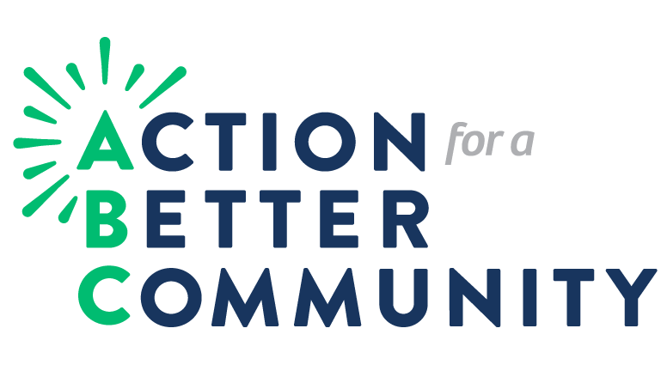

“Express Yourself”

Youth Essay Contest 2021!
Essay Question:

Reflecting on the Covid-19 Pandemic, how has the past year affected both you and your peers’ inner thoughts and feelings about the world around you and what applicable life lessons do you feel you have learned?

Action for a Better Community (ABC), has worked for over 55 years to promote and provide opportunities for families with low-income who live in Monroe and Ontario Counties. Our agency began from a small group of community leaders who recognized racial barriers, joblessness, and the need for affordable housing. This passionate group worked to create an agency that would address these very problems. Since then, ABC’s fight to eradicate poverty has never ceased; the agency is committed to expanding services and developing new initiatives. ABC’s Youth Services Department recognize youth as leaders who create positive change and play an important role in making an impact in our community.

High School Seniors we want to hear from you!
Eligibility
- High School Seniors in Monroe County

Essay Format
- Essay must be the original work of the student
- Essay must be submitted in English, typed in a 12 point font, and double-spaced
- Essay must have a word count of 500 - 700 words
- Essay must be submitted with a completed ABC Essay Contest Cover Page signed by a parent/guardian (A photo copy of the cover page is permitted)
- Sources must be cited (Only acceptable internet references include .org, .edu, or .gov)
  - For examples on citing resources go to: https://owl.english.purdue.edu/owl/resource/560/06/

Judging Criteria
- Well thought out and does not stray from the topic (worth 30 pts.)
- Creative, original, and reflect personal experiences or observations (worth 30 pts.)
- Well written with attention to grammar, spelling, and punctuation (worth 30 pts.)
- References that pertain to the point or argument being expressed (worth 10 pts.)

Contest Deadline
- Starts Friday, April 9th, 2021
- Ends 5pm, Friday, May 7th 2021
  - *No essays will be received after this date!

EMAIL SUBMISSIONS ONLY
Only in form of word document or pdf. (No links to google docs.)
Email to: Yvonne Wenzel ywenzel@abcinfo.org
**IN CASE OF EMAIL DELIVERY ISSUES PLEASE USE THE FOLLOWING ALTERNATE EMAIL ADDRESS FOR ESSAY SUBMISSION: ywenzelabc@gmail.com

Awards/Recognition
- One first prize winner will receive a Chromebook and $2000 scholarship
- Recognition and scholarship prizes will be given to 2nd and 3rd place winners
- The 1st place winner will be given the opportunity to read their essay at ABC’s Annual Meeting, date TBD.

For more information see your guidance counselor or contact:

Yvonne Wenzel
Youth Services Program Coordinator
Action for a Better Community, Inc.
Phone: 585-325-5116 ext. 3509
Email: ywenzel@abcinfo.org

ABC Essay Contest
Cover Page

Essay Topic: Reflecting on the Covid-19 pandemic, how has mental health among your peers been affected and what applicable life lessons have you learned?

Student Name: ________________________________ phone#: ____________

Address: _________________________________ Email: __________________

School: __________________________________________Grade: __________

(Winners will be notified by phone, so please have a working number available. Thank you!)

I consent to allow _____________________________to submit for consideration the attached essay. It is my understanding that any and all works submitted remain the property of Action for a Better Community. I do understand and consent that any essay may be used by Action for a Better Community for promotional purposes. I do consent to allow Action for a Better Community to use any photographs taken, or relinquished for future flyers, promotional materials for future essays, and for the purpose of the ABC website and/or newsletter. I do hereby remise, release, and hold harmless Action for a Better Community and its representatives, successors and assigns, now and forever from all actions, suits, claims, covenants, damages, executions, demands, and every other extent which I or our heirs, representatives, successors and assigns ever had and nor have and may ever have arising out of the aforesaid authorization and consent, or by any reason of any other cause of thing whatsoever, hereby relinquishing all interest therein and expressly waiving all claim and title thereto and therefore.

Student Signature: __________________________________________ Date: _________

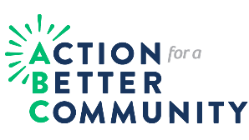
Parent/Guardian ___________________________________________ Date: _________

